**Current working of SPORF on Structured data: Circle experiment**

1. This is a two class classification experiment from points on a circle which makes the data dependent and hence structured.
2. Sequences are chosen at random and are non adjacent.
3. Two classes, 0/1: In 1 class, the sequences taking value 1 are of length 4 and 6 while in class 0, both sequences have equal length
4. This forms a structured data for classes, as the sequences are a part of the circle, each point has dependency on one another.
5. The experiments aim is to compare the performance of SPORF for such structured data against other classifiers and this is done through comparing the mean square error after classification.
6. I played around with the size of data and found various performance results.

Performance chart for sequence sizes: 8 & 2 for class 0 and 4 & 6 for class 1

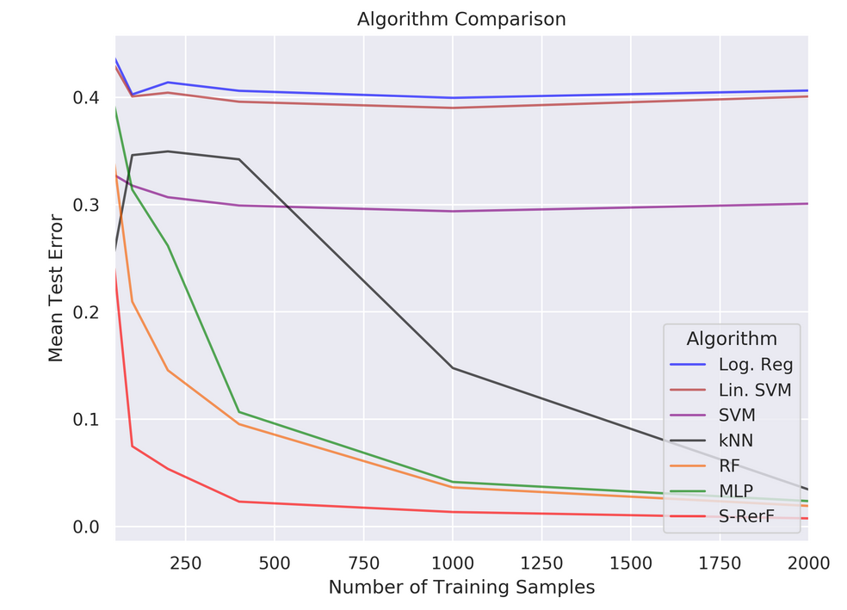

Performance chart for sequence sizes: 5 & 5 for class 0 and 4 & 6 for class 1

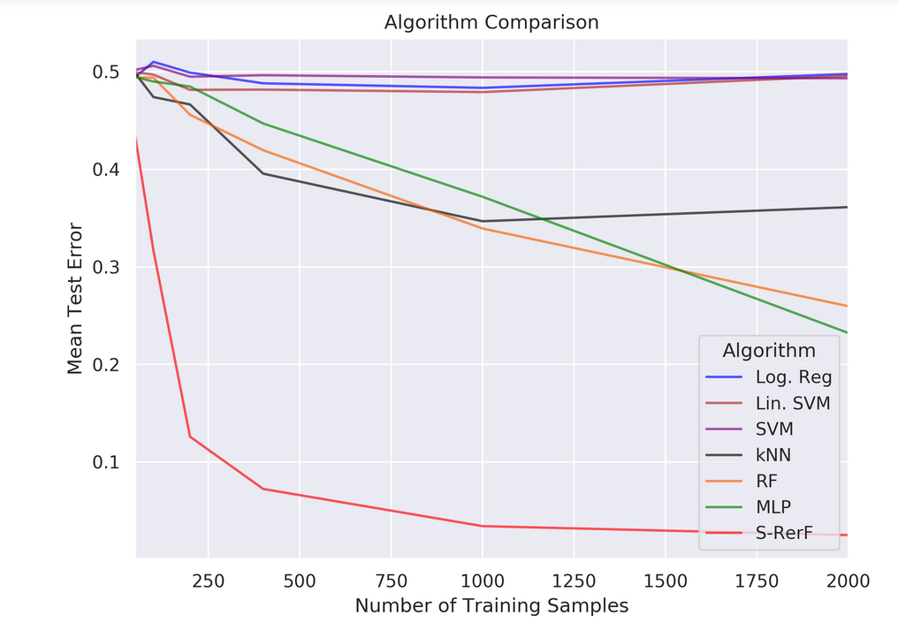

Performance chart for sequence sizes: 3 & 7 for class 0 and 4 & 6 for class 1

